

Mohd. Razia Alangir Banu
D. VENKAT SAI
2520090034
CSIT
CO-3

Case Study Topic: Meesho – Delivery Network Optimization & Route Management System

Work Done Summary:
Meesho operates delivery services across multiple cities and requires an efficient transportation network for order delivery. In this system, the delivery network is represented as a weighted graph where nodes represent warehouses or cities and edges represent delivery routes with transportation costs. BFS is used to identify all reachable delivery locations, while DFS is used for connectivity analysis and route exploration. Kruskal’s and Prim’s algorithms are implemented to construct a Minimum Spanning Tree (MST) that minimizes transportation costs. These graph algorithms help optimize delivery routes, reduce operational expenses, and improve delivery efficiency.
Implementation Details:
1. The delivery network is represented using a weighted graph structure.
2. BFS is used to explore reachable delivery locations level-by-level.
3. DFS is implemented for deep traversal and connectivity analysis between warehouses.
4. Kruskal’s algorithm is used to construct MST by selecting minimum-cost delivery routes.
5. Prim’s algorithm grows the MST using greedy minimum edge selection.
6. The final network minimizes transportation cost and improves delivery efficiency with optimized complexity.

Output:

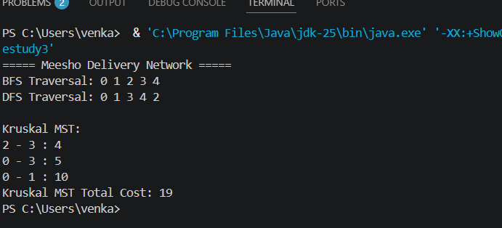

The Meesho delivery optimization system demonstrates how graph algorithms improve logistics and transportation management. BFS and DFS ensure proper connectivity analysis, while Kruskal’s and Prim’s algorithms help minimize delivery costs using MST concepts. This results in efficient and scalable delivery route management for large e-commerce operations.

Github Link: https://github.com/Venkat-267-byte/DSA-II

